# PJ Enterprises

# Electronic Product Guide Training

Facilitator Guide

© 2016 DesignFormation Performance.  All Rights Reserved.

# Table of Contents / Electronic Product Guide Training

Instructor Information 3

Content Introduction 3

Audience Information 3

Course Introduction 4

Training Timeline 4

Facilitator Tips 5

Preparation Checklist 6

Overview of Course Materials 7

Course Overview 8

Lesson One: Product Reference Guide Training 11

Topic A: Introduction 14

Topic B: Accessing the Product Reference Guide 14

Topic C: How to Use the Electronic Product Guide 15

Topic D Exercise—finding products using different search criteria 16

Topic E: Summary 17

Appendix C 43

Appendix D 44

Appendix E 45

Appendix F 46

## Instructor Information

### Content Introduction

This course is designed to increase telephone operators’ skills in product information and customer service, both of which are critical to improving call center efficacy and customer satisfaction. In this course, the electronic product guide course trains telephone operators in how to use the electronic product guide effectively. The result of implementing these courses will be a more viable call center team and raised customer service standards, addressing PJ Enterprises’ needs for growth expectations.   
Please note: this course is a prerequisite to the customer service training course.

### Audience Information

The participants for this training will include all telephone operators employed with PJ Enterprises. The audience characteristics are comprised of the following:

**Gender:** female

**Ages:** ranges from 18-60 years

**Education:** high school, GED, with some having completed a few college level courses

**Experience:** Experience ranges from new hires who have no prior work experience to seasoned operators employed either with PJ Enterprises or who come with similar work skills from another company. The telephone operators are familiar with basic software and computer commands. The procedures of how to use the electronic product guide as well as the new products presented during the training will be new information. The telephone etiquette and customer service training will provide new guidelines, procedures, and methods for interacting with customers. All have been informed that this is a new mandatory training. DFP has worked with the call center customer service supervisors from all shifts to provide input in the training materials and highly recommends they also participate in the training so that they are able to reinforce, monitor, and encourage the skills that are learned in the day to day operations. In addition, this will help them to be able to evaluate telephone operator performance of course objectives on the job. PJ Enterprises has a history of promoting customer service supervisors from working telephone operators, and therefore supervisors have the same learner characteristics and background, except with a longer time in service with PJ Enterprises.

## Course Introduction

**A. Course Outline for the Electronic Product Guide Training**1. Lesson One: Using the Electronic Product Guide to Search for Products

A. Lesson Introduction

B. Accessing the electronic product guide

C. Finding product information quickly in the electronic product guide using/search options

D. Exercise: Finding products using different search criteria

E.  Lesson One review and summary

2.  Using the Electronic Product Guide to identify product inventory Changes

A. Lesson Introduction

B. Accessing the electronic product guide

C. Identifying product inventory changes

D. Exercise: Identifying new and discontinued products using the search functions

E.  Lesson Two review and summary

F.  Closing out of the electronic product guide

G. Suggestions for further independent practice

### Timeline: Electronic Product Guide Training

This electronic product guide training should take approximately 2 hours total to complete, broken into two 60-minute lessons. The time duration for each given segment is approximate, but staying close to the given time allotment is important to complete the lessons’ material. Use this schedule to map your actual training lesson times.

1. Lesson One: Using the Electronic Product Guide to Search for Products [1 hour total]

 A. Lesson Introduction 5 min. \_\_:\_\_ to \_\_:\_\_

B. Accessing the electronic product guide 5 min. \_\_:\_\_ to \_\_:\_\_

C. How to Use the Electronic Product Guide 15 min. \_\_:\_\_ to \_\_:\_\_

D. Exercise: Finding products using different search criteria 25 min. \_\_:\_\_ to \_\_:\_\_

E. Lesson One summary 10 min. \_\_:\_\_ to \_\_:\_\_

2. Lesson Two: Using the Electronic Product Guide to Identify Product Inventory Changes [1 hour total]

A. Lesson Introduction 5 min. \_\_:\_\_ to \_\_:\_\_

B. Accessing the electronic product guide 2 min. \_\_:\_\_ to \_\_:\_\_

C. Identifying product inventory changes 15 min.   \_\_:\_\_ to \_\_:\_\_

F. Exercise: Identifying new and discontinued   
           products using  the search functions 20 min. \_\_:\_\_ to \_\_:\_\_

E.  Lesson Two review and summary 6 min. \_\_:\_\_ to \_\_:\_\_

F.  Closing out of the electronic product guide 2 min. \_\_:\_\_ to \_\_:\_\_

G. Suggestions for further independent practice 10 min. \_\_:\_\_ to \_\_:\_\_

## Facilitator Tips

Lesson Preparation

* Before each session plan for any unexpected challenges that might arise, such as an internet or computer outage, equipment failure, etc. Test all equipment at least one day prior to the training session.  If problems arise consult with your co-facilitator (if applicable), available supervisors, and IT staff to help resolve them.
* Read through the facilitator guide to familiarize yourself with the material. Review and practice presenting the information several times before the training.
* Display activity and role-play instructions on a slide or flip chart, in addition to them being available in the learner guide. This will allow participants to easily follow along as you are explaining what they will do. You can also use this to re-direct the group to instructions if the activity goes off-topic.

Time Management

* Keep track of time for each lesson. If you are sharing the responsibility with a co-facilitator, come up with a signal to alert one another when nearing the end of a time period.
* Highlight information or activities that you can cover more quickly or skip if you are running short on time. Have additional discussion points or examples on hand if the session is running short.

General Classroom Management

* Present the information in your own words. Familiarize yourself with the content and use the points on the slide or in the facilitator guide to remind you of important concepts to cover. This will allow for a more natural presentation and create a more relaxed and engaging experience for the learners.
* Encourage the group to share examples of personal experiences and share your own experiences when applicable as examples. The more real-world experience you can incorporate, the more the learners will feel valued and trust your expertise.
* Circulate around the front of the room, away from the podium and computer, when presenting information or leading a discussion. Your proximity to learners promotes higher engagement.
* Create a “parking lot” for participants to post questions that may arise that you can not address immediately. Tell the group that their questions will be addressed by the end of the lesson.
* Speak slowly and clearly. Allow adequate wait time after asking a question for participants to respond. By allowing up to 5 seconds of “wait time” you will find that the length and correctness of learner responses increase; the number of "I don't know" and no answer responses decreases; and the number of volunteered, appropriate answers by greater numbers of learners greatly increases.

Group Activity Management

* If a participant asks too many questions, state that you welcome the questions and encourage the participant to post them in the parking lot so you can address them. Remind the audience that questions in the parking lot will be addressed by the end of the session.
* If a participant dominates the conversation during large or small group discussions, kindly thank the person for the input and ask to hear opinions from others. If the person continues, speak to the person during the break and respectfully convey that others need to have the opportunity to contribute.
* During small group activities, briefly visit each group to ensure that everyone is participating. If you notice a group that is struggling or needs assistance, ask a leading question or suggest another direction they might explore.

## Preparation Checklist Instructor Information

Use the following to assist with preparation prior to the training class. One week prior to the class:

* Review this facilitator guide and be familiar with all of the content
* Review the PowerPoint slide presentation
* Get the attendee list
* Determine the amount of total participants
* Determine the logins needed for the training computers
* Make copies of the participant guide
* Make sure you have enough printed materials
* Communicate room set up requirements
* Acquire timer, flipchart/easels, markers, pens, pencils
* Review lunch arrangements and set up with PJ Enterprises contact

Day Before Training Class

* Confirm each training computer is set up with the PDF Reader
* Verify lunch order has been placed Verify scheduled start and end time
* Confirm room assignment

Day of the Class

* Gather Materials
* Participant Guides
* Job aid copies
* Evaluation Sheets
* Attendance Lists
* Blank paper for name tag/table tent
* Flipcharts
* Markers and Pens
* Arrive early to set up and test equipment
* Test PowerPoint and set it up to first slide
* Test YouTube Video and sound
* Verify restroom locations
* Set out handouts
* Set up timer
* Set up lunch area

## Overview of Course Materials

* Paper to create name tag/table tent
* Sign in sheet
* Easel and flipchart
* Markers for flipchart
* Pens and/or Pencils for participants
* Participant Guides
* Job aids (enough for each participant)
* Evaluation Sheets
* Attendance Lists
* Tally sheet for participant search results
* Handouts of user guide for note taking purposes
* Sample product ID code for demonstration
* Computers updated with New Product Reference Guide
* Timer (or clock)

## Course Overview Time: 15 minutes

|  |  |  |
| --- | --- | --- |
| **Tell:** Welcome to the Product Guide training class.  Let’s take a few minutes to give an overview for the class. |  | Welcome  elcome1.jpg |
| **Tell:** Let's go over the administrative items  **Explain:** elaborate on the details on each of the items on the slide |  | Administrative Details  dmin2.jpg |
| **Tell:** The participants your name, title, and background.  **Explain:** your experience and qualifications for facilitating the class.  **Ask:**  a) Each participant to write their first name on the paper in front of them and fold it long ways to form a table tent.  **Show:** participants an example of one you made for yourself. Allow 2 minutes for the participants to complete their table tent.  b) Go around the room and Introduce themselves by:   * first name * state their title and years service with BJ Enterprises * tell what they want to get out of the class.   **Explain:** during this training we will be completing activities and that the floor is open for any comments or feedback. |  | Introductions  ntro3.jpg |

|  |  |  |
| --- | --- | --- |
| **Tell:** participants that we will review the reasons and purpose of this course, and introduce the new product guide  **Explain:** This will assist the participants to become more familiar with the product guide to assist them with customers and provide better customer service  **Emphasize:** The importance of their contribution to the company’s success as well as their personal success in their job. |  | Purpose of Training  urpose4.jpg |
| Tell: **The objective of the course:** **Tell:** Given the electronic product guide, and keywords, and typical customer questions, participants will retrieve product details without error. Explain: **After the training is completed, they will be able to perform the objective.** **Emphasize:**how learning these skills will them attain and perform excellent customer service. |  | Course Objective |
| **Tell:** This is an outline of topics that will be covered today.  **Read:** the bullet points on the slide.  **Explain:**how each lesson builds on the skills learned in previous training, to form a robust skill set with regards excellent customer service at PJ Enterprises |  | Organization of Training  rg6.jpg |

|  |  |  |
| --- | --- | --- |
| **Tell:** This shows the agenda for the day.  This lesson will be 1 hour.  Lunch will be provided by PJ Enterprises.  You will break after this lesson is complete.  We will finish on time today. |  | Agenda for the Class  genda7.jpg |
| Ask: **Are there any questions?** **Explain:** the answers to any questions needed. |  | Questions  uestions8.jpg |

# Lesson 1:  Electronic Product Guide Training

## Timeline for Lesson One: Using the Electronic Product Guide to Search for Products [1-hour total]

**Instructor Note:** Fill-in time frames in the last column based on the time your session will run.

  A. Lesson Introduction 5 min. \_\_:\_\_ to \_\_:\_\_

  B. Accessing the electronic product guide 5 min.  \_\_:\_\_ to \_\_:\_\_

Demonstration 2 min. \_\_:\_\_ to \_\_:\_\_

Launch guides 3 min. \_\_:\_\_ to \_\_:\_\_

  C. How to Use the Electronic Product Guide 15 min \_\_:\_\_ to \_\_:\_\_

Search criteria 7 min. \_\_:\_\_ to \_\_:\_\_

How to search for products 8 min. \_\_:\_\_ to \_\_:\_\_

  D.  Exercise: finding products using   
 different search criteria 25 min. \_\_:\_\_ to \_\_:\_\_

Introduce the Scavenger Hunt! practice activity 2 min. \_\_:\_\_ to \_\_:\_\_

Model an example search 3 min. \_\_:\_\_ to \_\_:\_\_

Prompt individual learner practice 15 min. \_\_:\_\_ to \_\_:\_\_

Review activity / confirm correct answers 5 min. \_\_:\_\_ to \_\_:\_\_

 E.  Lesson One summary 10 min. \_\_:\_\_ to \_\_:\_\_

Review lesson 5  min. \_\_:\_\_ to \_\_:\_\_

Questions 5  min. \_\_:\_\_ to \_\_:\_\_

\\\\\

|  |  |  |
| --- | --- | --- |
| **Tell:** This next lesson will teach you how to use the new Product Reference Guide.  **Explain:**For telephone operators, part of providing excellent customer service includes being familiar with the product line of PJ Enterprises. Toward that goal, PJ Enterprises has designed a new user-friendly, searchable Product Reference guide in PDF form.  In this lesson, we will introduce you to the guide, its functionality and features and provide opportunities for you to practice using the guide.  **Emphasize:** The product reference guide is now in PDF form and it is organized differently. By learning these skills, finding products and referencing information about those products will take less time. The goal is to provide the best possible customer service experience for our customers. | lass.gif | Introduction  Slide 1: Introduction  https://lh5.googleusercontent.com/ZiY3nk-AcYrWiUGTXEKzoKZti7JRCkYpGvfAvR_lm1AjsAn3yvKUfNhjdC2fXIJ9SvOO9uy4nSMEeOsJ-5PLA8j3Xo4o_bG_iqpXonbED0MjuRa2bmIXbnQ1ca5wJMeCReIxLcG6 |

|  |  |  |
| --- | --- | --- |
| **Explain:** how finding products in a timely and accurate fashion is vital to excellent customer service, whether it be processing orders or returns, or product inquiries, and will help to reduce customer complaints. | eacher.gif | Importance  Slide 2: Why is this important?  mportance2.jpg |

|  |  |  |
| --- | --- | --- |
| **Tell:**where this lesson is in the course and how it connects the rest of the lessons.  **Explain:**that this lesson, along with the customer service training that they are also taking, will improve customer service by knowing how to talk to customers as well as having the base knowledge of products and the ability to better serve the customers in a timely manner.  This lesson will help you learn how to use the new product guide’s features efficiently while keeping the customers’ needs in mind. | eacher.gif | Overview  Slide 3: Overview  verview3.jpg |

|  |  |  |
| --- | --- | --- |
| **Explain:** In this lesson, you will use the new product guide to retrieve product details. You will be given keywords and typical questions. | eacher.gif | Objectives  *Slide 4: Course Objective*  bjective5.jpg |

|  |  |  |  |  |  |  |  |  |  |  |  |  |  |  |  |  |  |  |  |  |  |  |  |  |  |  |
| --- | --- | --- | --- | --- | --- | --- | --- | --- | --- | --- | --- | --- | --- | --- | --- | --- | --- | --- | --- | --- | --- | --- | --- | --- | --- | --- |
| **Tell:**  This lesson covers how to access the product reference guide, how to read a product information page, how to conduct a search for a product and the ways to do that, and has a scavenger hunt game where you will practice finding sample products.  **Explain:** Each topic builds on previous topics learned, so at the end of the lesson, you should be able to use the product reference guide completely.  **Tell:** Write down any questions or concerns you have during the lesson and we discuss and answer them by the end of the session. | eacher.gif | Topics  This lesson includes the following topics:   |  |  |  | | --- | --- | --- | | Topic | Page | | | 1 | Introduction |  | | 2 | Accessing the Product Reference Guide |  | | 3 | How to Read the Product Reference Guide |  | | 4 | How to Search for Products |  | | 5 | Activity-Scavenger Hunt |  | | 6 | Summary |  | | 7 | Questions |  | |

|  |  |  |
| --- | --- | --- |
| Topic A: Introduction | | |
| **Tell:** This topic focuses on showing you how to use the search capacity of the product reference guide.  **Explain:**  Remind learners that this document is the same as the printed form, but is interactive and quickly searchable. | lass.gif |  |

|  |  |  |
| --- | --- | --- |
| Topic B: Accessing the Electronic Product Guide | | |
| **Tell:**  This topic covers accessing the product reference guide.  “On your terminals, double click the PJE Electronic Product Guide” icon. This document will stay open and active after launching it, until closing. It is not editable.  **Explain:** Opening this doc will be your first action before starting calls in the future, and learning how to navigate it will improve your working experience. | emonstration.gif | The electronic product guide is easy to find on the desktop of your workstation.  To access the guide:   * Go to the desktop screen * Find PDF file called “PJE electronic product Guide p17.pdf” * Double click the icon   con_pg.jpg |

|  |  |  |
| --- | --- | --- |
| Topic C: How to Use the Electronic Product Guide | | |
| **Tell:**  This electronic product guide is organized in the same way as the paper guide, but allows you to navigate between pages and topics using search criteria.  **Explain:** Instead of turning pages, think in terms of keywords and categories. | emonstration.gif | Reading the product guide  You can look for items under several information fields, including these highlighted below:   * Item Name * Item Number * Category * Sub-category * General Description * Brand Name * Keyword   uide3.jpg |

|  |  |  |
| --- | --- | --- |
| **How to Search for Products (Topic C continued)** | | |
| **Tell:**  Open up a search field by selecting  [ctrl - F].  You can use this field to enter search criteria to find product information. In this field you can enter a range of search criteria: search by keyword, item name or number, department, category, or brand name.  **Explain:** Searching by keywords and categories gives you more options to locate a product or product information quickly during a call. | emonstration.gif | Press CTRL + F to open up the search field, which will open in the top right hand corner of the screen.  You can search using any of the criteria we showed above in an example  earch4.jpg |

|  |  |  |
| --- | --- | --- |
| Topic D: Exercise—finding products using different search criteria | | |
| **Tell:**Now it’s your turn to find products. Using the electronic product guide, you’re going on a scavenger hunt using the keyword search function to find specific products or product details.  Practice example:  Find the price of the Collapsible Storage Ottoman.  **Explain:** Finding the product page with the price is a quick process, particularly if you know the exact product name.  (Facilitator models the search and finds answer: $37.00)  See the sample product guide model slide, the Scavenger Hunt answer tally sheet in appendices E and F. | xercise.gif | odel scavenger hunt search.jpg  C:\Users\Jill Ballard\Documents\stout UoW\EDUC 768\mod 7\scavenger hunt slides and answers\scavenge example ottoman example.jpeg |

|  |  |  |
| --- | --- | --- |
| Share the correct answers.  See the sample product guide model slide, the Scavenger Hunt answer tally sheet in appendices E and F. |  | C:\Users\Jill Ballard\Documents\stout UoW\EDUC 768\mod 7\scavenger hunt slides and answers\scavenge Q7.jpegC:\Users\Jill Ballard\Documents\stout UoW\EDUC 768\mod 7\scavenger hunt slides and answers\scavenge Q6.jpeg  C:\Users\Jill Ballard\Documents\stout UoW\EDUC 768\mod 7\scavenger hunt slides and answers\scavenge Q5.jpeg3.5  C:\Users\Jill Ballard\Documents\stout UoW\EDUC 768\mod 7\scavenger hunt slides and answers\scavenge Q4.jpegC:\Users\Jill Ballard\Documents\stout UoW\EDUC 768\mod 7\scavenger hunt slides and answers\scavenge Q3.jpegC:\Users\Jill Ballard\Documents\stout UoW\EDUC 768\mod 7\scavenger hunt slides and answers\scavenge Q2.jpeg3.5  C:\Users\Jill Ballard\Documents\stout UoW\EDUC 768\mod 7\scavenger hunt slides and answers\scavenge Q1.jpegC:\Users\Jill Ballard\Documents\stout UoW\EDUC 768\mod 7\scavenger hunt slides and answers\scavenge Q8.jpeg |

|  |  |  |
| --- | --- | --- |
| Topic E: Summary | | |
| **Tell:**  In this lesson, you’ve learned about searching the electronic product guide, using different search criteria, and have located product information yourself. The more you practice with the guide, the easier it’ll be to think in terms of search criteria.  **Explain:** Being able to successfully search the electronic product guide is your foundation for helping customers, both politely and efficiently. And it shows your knowledge of the PJE product inventory. | eacher.gif | Debrief: Describe your experience using the electronic product guide.   * How did it compare to the paperback version? * Was it easy to use? * Did this training cover everything you think it needed to? * Do you feel more comfortable now with the ability to answer questions about products?   Write your thoughts on separate paper, or use the back of the scavenger hunt tally sheet (appendix E) |

|  |  |  |
| --- | --- | --- |
| Questions | | |
| **Ask:**  What questions did you have in the product search? —with the guide in general? —with the process of searching? How do you think you’ll use these skills in your daily work?  **Do:** invite learners to consider how they’ll use the product guide on the job, and what questions may arise regarding its use. | uestion.gif | uestions8.jpg | |

# Please find the Customer Service Training beginning on the next page.

# PJ Enterprises

# Customer Service Training

Facilitator Guide

© 2016 DesignFormation Performance and PJ Enterprises.  All Rights Reserved.

## Table of Contents / Customer Service Training

Instructor Information 21

Content Introduction 21

Audience Information 21

Course Introduction 22

Training Timeline 23

Facilitator Tips Overview 24

Preparation Checklist 26

Overview of Course Materials 27

Course Overview 27

Lesson B5-C Handling a Return 30

Topic 1 Introduction 31

Topic 2 Return Policy and Types 33

Topic 3 Confirming Customer Information and Determining Return Eligibility 34

Topic 4 Instructing Customers Regarding Return Labels and Shipment 35

Topic 5: Practice! Role play 36

Appendix A 39

Appendix B 40

# Instructor Information

## Content Introduction

This is the second training in a two-part course is designed to increase telephone operators’ skills in product information and customer service, both of which are critical to improving call center efficacy and customer satisfaction. The electronic product guide course is a prerequisite to this training. This customer service course focuses on strengthening telephone operators’ phone etiquette and customer service skills to meet customers’ needs more efficiently and politely. The result of implementing these courses will be a more viable call center team and raised customer service standards, addressing PJ Enterprises’ needs for growth expectations.

## Audience Information

The participants for this training will include all telephone operators employed with PJ Enterprises. The audience characteristics are comprised of the following:

**Gender:** female

**Ages:** ranges from 18-60 years

**Education**: High school, GED, with some having completed a few college level courses

**Experience:** Experience ranges from new hires who have no prior work experience to seasoned operators employed either with PJ Enterprises or who come with similar work skills from another company. The telephone operators are familiar with basic software and computer commands. New information will include procedures for how to use the electronic product guide as well as the new products presented during the training. The telephone etiquette and customer service training will provide new guidelines, procedures, and methods for interacting with customers. All employees and supervisors have been informed that this is a new mandatory training. DFP has worked with the call center customer service supervisors from all shifts to provide input in the training materials and highly recommends they also participate in the training so that they are able to reinforce, monitor, and encourage the skills that are learned in the day to day operations. In addition, this will help them to be able to evaluate telephone operator performance of course objectives on the job. PJ Enterprises has a history of promoting customer service supervisors from working telephone operators, and therefore supervisors have the same learner characteristics and background, but are differentiated by their longer service and experience at PJ Enterprises.

**Prerequisites**: Learners have completed the electronic product guide training course.

## Course Introduction

### Session One: Telephone Etiquette Basics

1. Lesson One: Using appropriate greetings and introductions

A.     Lesson Introduction

B.    Overview of basic call greetings

C.    Greeting and introduction composition

D.    Exercise: Using appropriate greetings and introductions with given scenarios

E.     Lesson One review and summary

2. Lesson Two: Following basic conversation flow

A.     Lesson Introduction

B.    Overview of conversation flow principles

C.    Critiquing examples for discussion

D.    Exercise: Using order phrases in conversation flow

E.     Exercise: Using conversation flow principles with given scenarios

F.     Lesson Two review and summary

3. Lesson Three: Using tone, pace, and volume on a call

A.     Lesson Introduction

B.    Overview of the impact of non-verbal signals

C.    Demonstrating examples and counterexamples

D.    Critiquing audio examples for tone, pace, and volume

E.     Exercise: Role-play with given scenarios

4. Lesson Four:

A.    Lesson Introduction

B.    Overview of basic call features; call closings

C.    Write a closing

D.    Sharing with partner for feedback

E.     Exercise: Practicing closings with given scenarios

F.     Lesson Four Review and summary

G.   Session One summary

### Session Two: Customer Service Skills

5. Lesson Five: Taking orders

A.     Lesson Introduction

B.     Overview of customer service procedures relating to orders

C.     Engaging efficiently with customers and handling their inquiries.

D.    Exercise: handling orders

E.     Lesson Five review and summary

6. Lesson Six: Defusing upset customers

A.     Lesson Introduction

B.    Defusion strategies (i.e., CARP control/acknowledge/refocus/problem solve)

C.    Guidelines of when to transfer to a supervisor

D.    Exercise: Developing practice scenarios and strategy plans

E.     Exercise: Using strategies with given scenarios

F.     Lesson Six review and summary

7. Lesson Seven: Using sales strategies

A.     Lesson Introduction

B.    Overview sales strategies

C.     Exercise: Upselling or cross-selling

D.    Discuss and review

E. Share real on-the-job experiences in question and answer segment

F. Lesson Seven review and summary

G. Session Two summary

### Timeline

The customer service training is a total of 8 hours divided into two 4 hour long sessions. The lesson topics detailed below in the facilitator guide should take approximately 30-40 minutes to complete. Timing is flexible within a 10-15 minute plus or minus time frame. You can adjust based on needs of the audience.

## Lesson Topic Outline

Topic 1 Introduction

Topic 2 Call

Topic 3 Open the call

Topic 4 Customer engagement

Topic 5: Information Gathering

Topic 6: Return specifics (item, exchange methods)

Topic 7: Return Logistics (i.e. return labels and shipment)

Topic 8: Closing the call

Topic 7 Activity-Role Play of Service Recovery Scenarios

Topic 8 Summary

# Preparation Checklist Instructor Information

## Facilitator Tips Overview

Lesson Preparation

* Before each session plan for any unexpected challenges that might arise, such as an internet or computer outage, equipment failure, etc. Test all equipment at least one day prior to the training session.  If problems arise consult with your co-facilitator (if applicable), available supervisors, and IT staff to help resolve them.
* Read through the facilitator guide to familiarize yourself with the material. Review and practice presenting the information several times before the training.
* Display activity and role-play instructions on a slide or flip chart, in addition to them being available in the learner guide. This will allow participants to easily follow along as you are explaining what they will do. You can also use this to re-direct the group to instructions if the activity goes off-topic.

Time Management

* Keep track of time for each lesson. If you are sharing the responsibility with a co-facilitator, come up with a signal to alert one another when nearing the end of a time period.
* Highlight information or activities that you can cover more quickly or skip if you are running short on time. Have additional discussion points or examples on hand if the session is running short.

General Classroom Management

* Present the information in your own words. Familiarize yourself with the content and use the points on the slide or in the facilitator guide to remind you of important concepts to cover. This will allow for a more natural presentation and create a more relaxed and engaging experience for the learners.
* Encourage the group to share examples of personal experiences and share your own experiences when applicable as examples. The more real-world experience you can incorporate, the more the learners will feel valued and trust your expertise.
* Circulate around the front of the room, away from the podium and computer, when presenting information or leading a discussion. Your proximity to learners promotes higher engagement.
* Create a “parking lot” for participants to post questions that may arise that you can not address immediately. Tell the group that their questions will be addressed by the end of the lesson.
* Speak slowly and clearly. Allow adequate wait time after asking a question for participants to respond. By allowing up to 5 seconds of “wait time” you will find that the length and correctness of learner responses increase; the number of "I don't know" and no answer responses decreases; and the number of volunteered, appropriate answers by greater numbers of learners greatly increases.

Group Activity Management

* If a participant asks too many questions, state that you welcome the questions and encourage the participant to post them in the parking lot so you can address them. Remind the audience that questions in the parking lot will be addressed by the end of the session.
* If a participant dominates the conversation during large or small group discussions, kindly thank the person for the input and ask to hear opinions from others. If the person continues, speak to the person during the break and respectfully convey that others need to have the opportunity to contribute.
* During small group activities, briefly visit each group to ensure that everyone is participating. If you notice a group that is struggling or needs assistance, ask a leading question or suggest another direction they might explore.

## Preparation Checklist Instructor Information

Use the following checklists to assist you in class preparations prior to the training class.

One week prior to the class

* Review this facilitator guide and be familiar with all of the content
* Review the PowerPoint slide presentation
* Get the attendee list
* Determine the number of participants
* Determine the logins needed for the training computers
* Make copies of the participant guide
* Make sure you have enough printed materials
* Communicate room set up requirements
* Acquire timer, flipchart/easels, markers, pens, pencils
* Review lunch arrangements and set up with PJ Enterprises contact
* Day Before Training Class
* Confirm each training computer is set up with the PDF Reader
* Verify lunch order has been placed
* Verify scheduled start and end time
* Confirm room assignment

Day of the class

* Gather Materials
* Participant Guides
* Job aid copies
* Evaluation Sheets
* Attendance Lists
* Blank paper for name tag/table tent
* Flipcharts
* Markers and Pens
* Arrive early to set up and test equipment
* Test PowerPoint and set it up to first slide
* Test YouTube Video and sound
* Verify restroom locations
* Set out handouts
* Set up timer
* Set up lunch area

## Overview of Course Materials

* Paper to create name tag/table tent
* Sign in sheet
* Easel and flipchart
* Markers for flipchart
* Pens and/or Pencils for participants
* Participant Guides
* Job aids (enough for each participant)
* Evaluation Sheets
* Attendance Lists
* Handouts of user guide for note taking purposes
* Sample product ID code for demonstration
* Computers updated with New Product Reference Guide
* Timer (or clock)

Timeline: Allow approximately one minute for slides 1-7 and approximately 3 minutes for questions for slide 8. A maximum total time of 10 minutes.

# Course Overview Time: 10 min.

|  |  |  |
| --- | --- | --- |
| **Tell:** Welcome the group to Customer Service Training Let’s take a few minutes to give an overview for this class. |  | **Welcome**  Slide 1: Welcome  https://lh4.googleusercontent.com/6iZMTZVriQ4kScAYnPmiKGPVjchVxMdW3-dh-mxakKuEPMt_tLWasutAlnV2nk-Tov02zoSaZdziLYG_j2Sg8bFo2pzYWYC2xCDsh6v0J2RdWktInF-qfTCq-Ltv7JKwr5crliFU |
| **Tell:** Let’s review the administrative items before getting started.  **Explain:** elaborate on the points shown in the slide. |  | Administrative Details Slide 2: Administrative Details  https://lh5.googleusercontent.com/ZqFJUqZz1I9RYBDQFdq5--HFTfFTdforUPN28JAnJ_tAYs02-jFUloWYEPtDGgV_U2FKoyvts4VwkAp3V3rC8Z4W_Xt8K1YDtzOVaS_oPqQuIQQonXlWdVVioUhJ6dYkHSKo--zK |
| **Tell:** Give the participants your name, title, and background.  **Explain:** your experience and qualifications for facilitating the class.  **Ask:** participants to get out their name cards from the previous training and set it in front of them. |  | Introductions Slide 3: Introductions  https://lh6.googleusercontent.com/JA49O5HI3UlHx4uhilqanbkl555xdztY1LfyoR5GgEWAtOUhmjb4kOZWLhVZtbVn3VUYfD0pipfDJiFt3MSrZqw_RE-YIalFk00qxGXQ62xnorl9wOQGqAk7--yZ0CnAQy4ArRAB |
| **Tell:** The purpose today is to strengthen and streamline telephone etiquette and customer service skills to better meet customers’ needs more efficiently.  **Explain:** elaborate on the points on the slide as to what skills this lesson will specifically address. |  | **Purpose of Training**  Slide 4: Purpose of Training  https://lh5.googleusercontent.com/ZiwCDC0a5b2Q8Uq-eMBzDc8kRUHMzoAoMWABr4Z5LYh1juwQkkxZyFY4Oxj10-iuYnit7LZJBgtvuM4bYRIwa13Bm1DEs3sUugPpoAR5fvpYKfzV7Po1WOM1d0lLj74ewDxKZObi |

|  |  |  |
| --- | --- | --- |
| **Tell:** information learned in this part of the course will connect back to the electronic product guide training and skills learned in part one of the customer service training.  **Explain:** Briefly highlight some of the skills they will incorporate shown on the slide. |  | **Pre-requisites of Training**  Slide 5: Prerequisites of Training  https://lh5.googleusercontent.com/nwUKx49GuMfTlrZbEsj98qo3AVpY24XfBD1OgKE25hXcV8zeVwnDRcQDHebNzFSYz7qoKgLk2naL8pJsAELoO80aTUneg_JpM7O-wOsbizUtwIXDASrO5IEb5sNZcWGNrfYAcssE |

|  |  |  |  |
| --- | --- | --- | --- |
| **Tell:** By the end of part two of the customer service training course these objectives will be covered.  **Explain**: Give participants the opportunity to read them independently in their learner guide. If there are questions encourage them to write them in the parking lot. |  | **Course Objectives**  Slide 6: Purpose of Training  https://lh6.googleusercontent.com/a2_8omr1LISifDVK6fbISUfx6PIOaGlZPM0nJuH_GX3oBPiPOAFASoroI-PBovZ-JoIE2EpwcI0wiXQrd8PNtYVDsfYW9jdRikeIBtDQzvpYbUN9MjHgOKDdefH-xcYDS5RV5s79 | |
| **Tell:** This is an instructor-led facilitated training.  **Explain:** Class includes whole group instruction and small- group work in a classroom environment. Re-emphasize that skills learned in this class will build upon previous skills from the previous trainings. |  | Organization of Training  Keep Slide 5 Purpose of Training here. |

|  |  |  |
| --- | --- | --- |
| **Tell:** This is an outline of the information that will be covered today. This lesson will be approximately 30-40 minutes.  Lunch will be provided by PJ Enterprises.  Break will occur after the class is completed  You will finish on time today.  **Note:** Adjust agenda accordingly if last minute schedule changes occur. |  | **Agenda for the Class**  Slide 7: Agenda  https://lh6.googleusercontent.com/MlAB5hfB15Zoey5xV9LumMKVjerFuthB23dllbZs1GfPPh5F_dvcCM4ZpCtNQEvVz5xjbI5b--murqulQ7Ncl8VgAS2Ag76yQnI6qzHqwsnMddpYMbADiccW3jfV4rNWduRJdYYH |
| **Ask:** Are their any questions?  **Explain:** Answer any questions relevant to the material just presented. Remind participants to write questions in the parking lot as they arise throughout the class if they do not relate directly to information being covered. |  | **Questions**  Slide 8: Questions  https://lh6.googleusercontent.com/yRYXsf7MCQAgEUg3SkQGgHCoFPRE-bg2IjnJBtplF7uDrc6PXcBaGa369R6i3XaohEhcM5lcneerRvK9cPoda74zvUn1YoW0XkHe4bl6dMvSAiKiH2hO92kPNEeXV0Ta6Dl32YI- |

0

# Lesson B.5C:  [Engaging efficiently with customers and handling their inquiries—Handling a Return] Time:  40 min.

(Time is based on this lesson being one of 7 lessons in the 4 hour training per DFP’s proposal)

## Timeline for Lesson B.5C

### Engaging efficiently with customers and handling their inquiries—Handling a Return

Instructor Note: Fill-in time frames in the last column based on the time your session will run.

|  |  |  |
| --- | --- | --- |
| Introduction | 5 minutes | \_\_:\_\_ to \_\_:\_\_ |
| Return policy | 5 minutes | \_\_:\_\_ to \_\_:\_\_ |
| Confirming customer information and determining return eligibility | 5 minutes | \_\_:\_\_ to \_\_:\_\_ |
| Instructing customer regarding return labels and shipment | 5 minutes | \_\_:\_\_ to \_\_:\_\_ |
| Practice—Role play scenarios | 20 minutes | \_\_:\_\_ to \_\_:\_\_ |

|  |  |  |
| --- | --- | --- |
| Introduction (5 minutes) | | |
| Tell: This next lesson will teach how to efficiently process a return while applying the principles of great customer service.  Note: This lesson includes the following topics:   |  |  |  | | --- | --- | --- | | Topic | | Page | | 1 | Introduction |  | | 2 | Return policy and types |  | | 3 | Confirming customer information and determining return eligibility |  | | 4 | Instructing customer regarding return labels and shipment |  | | 5 | Practice! Role Play Scenarios |  |   **Explain:** For telephone operators, part of providing excellent customer service includes being able to process returns accurately and in a timely manner while maintaining a positive rapport with the customer. | *lass.gif* | Topics Overview  *Slide 9: Topics Overview*  https://lh6.googleusercontent.com/6rMaa-6Pz6o9kdvw-w1gqMaHzWZPh1lVVYGpbWyoxVz-elToEi7V4ucZrjcb9ptjiDWPDQY2xB7cH0sfml0cjecg0QUhdPNep2I2qlksyK4vNdJN-f6UMGYeCB_HEHutt2KyvMg9 |
| **Tell:** As a mail-order catalog retailer, product returns and refunds are a necessary part of business.  **Explain:** There are a variety of reasons customer may want to return their purchase.  **Tell:**  PJ Enterprises guarantees 100% satisfaction with the product within one year of date of purchase, with certain restrictions. |  | **Introduction**  Slide 10: Introduction  https://lh5.googleusercontent.com/cHCoAF4ICmEij-Km-Mh4rH3dBohMmUuwaa6hnv6adXDKqOBHz3dsUTVpdLKCLAazSrmgURb4gXNPfzPFsGdhmDX80swynKt4cOA0VuAWTYsRcfvf1fJa5y2wy5JQFL-_B7tlr0Kq |

|  |  |  |
| --- | --- | --- |
| **Tell:** As telephone operators, you’re the ambassadors of the company. As ambassadors, you’re responsible with representing the company and building a lasting relationship with the customer.  **Explain:** It’s important to handle product returns smoothly and professionally. Your conversation with them about the return is another point of contact they’ll have with our company, and another chance to build that relationship. If you succeed, you’ll will have them bringing their business back as return customers, and referring PJ Enterprises to others. |  | **Importance**  Slide 11: You are important to the process  https://lh3.googleusercontent.com/qlCPrMo_xV-93KLT-iEbegnw8K0QfKIhANwzdpMXEU9n7Htxt_Ww8kZ8umdrvRz4zwVnWJhajzYwhiiJ_9-uetCgz_ClHwhfmqKBDl2SQEEfgbo-zeR-ZvktDyfv0zGpP66FG3i4 |
| **Tell:** After this lesson, you’ll be use order phrases and conversation flow principles to be able to apply techniques you’ve learned in previous training to open and close calls,  **Explain:** Briefly summarize the bullet points on the slide. Emphasize that the focus will not just be on the processes themselves but the manner in which they interact with a customer.   * Confirm necessary customer information and reason for the return * Suggest appropriate solutions based on the given return type and situation * Provide instructions to the customer regarding how to return product for credit or exchange for a product of equal value |  | **Objectives**  Slide 12: Lesson Objectives  https://lh5.googleusercontent.com/5injrAk5awr0S20b7Ki6ngU4vIRRqwj6Y8EaFclsEIWECWtmzl_9KLnCSOQVIgCNyfwXSbufm-vYbsjuzr-LKadUACgE6dlxUUFYJGpVuKdPIEP-Feu2x4sRKzFrYTV-vDhF_sDp |
| **Reflection**  Note:Lead a short question and answer discussing participant responses briefly to activate prior knowledge  **Ask:**   1. Have you ever had to return a product to a company? 2. What are some reasons you’ve had to do so? 3. What can make returns frustrating, either from what you know about our product/customers, or from your own experience? 4. What are some things a company has done to make your own returns a positive experience? 5. Do you like being on hold or being transferred to someone else?   Tell: Let’s listen to an example call.  **Do:** Play audio example of a call that is missing key customer service components and demonstrates insufficient knowledge of returns policy.  **Ask**: What challenges or frustrations did you hear in this call?  **Answer:** Accept and discuss all reasonable responses (Telephone operator interrupted the customer before they could finish explaining their issue, didn’t get the date of purchase and other key information about the reason for the return, instructions on how to process the return were confusing)  **Transition:** Let’s review our return policy so you can save yourself from running into the same pitfalls during your own calls. | https://lh6.googleusercontent.com/js1c-Of2f2ertBm1L8-ApCwwZBy5xLEYp-W0Y6GfK-SFTm8WooIOw7hjbndotzM6rNDAtZLofxYE8E_Dr0E71y93EGEYimtQUrgmLK7IVTKPpcj_TDbjOJKuflFfrvrtLijkYTS6  https://lh3.googleusercontent.com/wttyKtbbg0efnxw0TenEWld3Rgfn2J2NtYHR4QdCDsuc96Zx2BenuiT0dctT9rKT5M5A3QF05dFYbIjc1NOndGFAgPTiZWPtxpsv4__GngCJkmNZIHqfL8LcEZ99xzyLjZxtNr5A |  |
| 2. Return policy and types (5 minutes) [cs] | | |
| **Tell:** There are various reasons a customer might want to return a product.  **Ask:** Think about the last product you returned.  What were some reasons you wanted to return the product?  Note: Use a flipchart to record participants’ responses. After collecting a few reasons to return products from participants, present them with *Slide 13: Reasons for returns.*  **Tell:** Any of these reasons are valid to be able to return a product as long as the return adheres to PJ Enterprises Return Policy.  Note: Show *Slide 14: PJ Enterprises Return Policy*  All unused products are eligible for return 1 year after date of purchase. This return policy does not cover ordinary wear and tear caused by improper use or accidents.  Return Criteria:   * All original product packaging must be intact and tags must be attached. * Packing slips and any manufacturer’s documentation must also be returned with the product.   If the product meets return policy and criteria, products may be returned for credit or exchanged for a product of equal value.  Note: Show *Slide 15: PJ Enterprises Return Policy (2)* |  | *Slide 13: Reasons for returns*  https://lh6.googleusercontent.com/UllMhupmJjo2TXVVDBvfCY50sMpAGwWhG5eahbSuTIMkkKa6a5Cx0yjNtt5JKf0R_8ws9bxyA3Tl9cTHQL6OG3jkmRFAkXKxp-fUKXsG2tmyGFZ_xhJojgU7ImR_hJx9Vm3c6i19  Slide 14: PJ Enterprises Return Policy  https://lh6.googleusercontent.com/plc4OZQ1IbFpEfxdSkV0Kk1GwIG9mQdW9z0IXGC4AvRJDFfHleaO3ojFBfX42IqnjJYD3FWyjmkzoMCKh_GAYXyEJhPQM-fikIN53RdjJs8ngbXeOltR9fnVIAnPLzFzJgMxo5V9  *S*lide 15: PJ Enterprises Return Policy (2)  https://lh5.googleusercontent.com/bLhuM6yRihxBVE9RMTjUuwJwJOMg39gbwKYL4iYyo3vD7NxktfNpVAcuMfotNQwNPo3PUePmJHwfUbgEU_jpSIy29mydLEz6TqpPnq3UENho3pb6F778zTSJGNgMkYkoTW2NPPfl |
| **Transition:** Let’s confirm customer information and determine whether their product is eligible for return. First, let’s consider some scenarios together to decide if a return can be done or not.  Verbally share the following scenarios with the group one at a time and ask for a show of hands for an answer of *yes* and to keep hands down for and answer of *no*.  **Scenario 1:** Product arrives damaged.  *Answer:* yes  **Scenario 2:** Customer accidently dropped and broke a coffee cup she ordered while taking it out of the packaging.  *Answer:* no  **Scenario 3**: Package arrived too late and customer no longer needs the item.  *Answer*: yes  **Scenario 4:**  A wreath was bought 6 months ago, and the customer hung it on her front door but has decided it does not compliment her décor. She wants to return it.  *Answer:* no |  |  |
| 3. Confirming customer information and determining return eligibility (5 minutes) | | |
| **Ask:** What information can you use to find the customer’s specific product order in the least amount of time?  *Answer:* Order number  **Tell:** Once it’s established that the customer is requesting a return, you will need to pull up their order and verify that it is the correct account.  **Explain:**   1. *Order Number*: The first thing to ask is for their order number.  With that, you will be able to immediately pull up their order information on the order entry system. 2. *First/Last Name*: Ask the customer to verify the first and last name of the person who purchased the item.   After the customer information has been pulled up and verified, you need to confirm that the product is eligible for return. How do you do that?  You confirm the date of purchase in their order information.  **Ask:** If a customer bought gloves on Dec. 7, 2016, what would be the latest date a return could be made?  Answer: Dec. 7, 2017  **Explain:** Unused products are eligible for 1 year after date of purchase. If the product is eligible for return, go over the return policy and criteria with the customer. Ask the customer to provide a reason for returning the item and record the response in the entry system. If the product is ineligible for return, apologize and inform the customer that the return is not possible. | lass.gif | Slide 16: Confirm Customer Information  https://lh3.googleusercontent.com/rD-ynLoc-Q7qPYjvsFEFWwCmAtfZ88RlESIu_0BJFwg7eB7DVvBSTGZxry8tB0gYCkUG-F6L-YAYEg_448y6yddzHVkR8iRqkAOizgdDRqVuWUfVBH_9L-unr00HOM66gEmFLI_6  Slide 17: Return Eligibility  https://lh5.googleusercontent.com/U9Ojf0ELmd_0XFsDFBjd1f5eNUhE1hbCLzRICkQZNsTOr4xpFIQPTHIsNMeLumF16gTk-APToJy0j6mhp1Z9PCRKOXwgOz0eX3rye1dfPPPkI7QH8t0DZJEMAs--C7xWMMJPnzJL |
| 4. Instructing customer regarding return labels and shipment (5 minutes) [cs] | | |
| **Tell**: Customer return shipments are completed in an easy 1-2-3 step process:  **Explain:** Attached to their packing slip is a pre-addressed, sticker label for free returns.  Customers need only:   * Prepare the return shipment * Attach the pre-addressed, sticker label to the package * Drop off at any UPS store.   Customer return shipments must include:   * Unused product in original packaging with all tags attached * Original packing slip * Any manufacturer’s documentation   **Transition:** Let’s practice what you learned with some role play scenarios. | *lass.gif* | Slide 18: 123! Customer Return Shipment  https://lh3.googleusercontent.com/gr8kJo6u82YfeVbGMpyOS4MHrkN2qKfAv4N5FdAIKz8of_Gl1fwl2kBGU-cv05NMbfsC_ke2K8aLCq7yHtMTr0cN8tUgUSdFdHsT1ODcJVEJ0Mq1gwsH9W-0nVBxqgYtiegykynJ  Slide 19: Return Shipment Criteria  https://lh6.googleusercontent.com/lkRZM6EEKcPFAxExvv5oiJ86bIjtJfmk3ywWG9T6aw8hbiOHpTogNxB_G57JcSo49GJemUQNN4i_LYyMbaAM_vE3K0NpxoFXzdmm6rxRrvazYmKoXt-OAvrswftrFaobx7eZ-AMh |
| 5. Practice! Role Play Scenarios (20 minutes) | | |
| [2 minutes]  **Review**: Five Customer Service Principles covered previously: Listen-Clarify-Express Empathy-Be Patient-Be Courteous  **Explain:** Telephone operators are responsible for making interactions with customers warm and professional. Each call is different, another new opportunity to make a positive connection. This is a critical part of what we do every day as the “face” of PJ Enterprises.  Being mindful of PJ Enterprises Customer Service Standards will help us continue to build long-term relationships, brand loyalty, and trust. | *lass.gif* | Listen-Clarify-Express Empathy-Be Patient-Be Courteous  Slide 20: Five Customer Service Principleshttps://lh6.googleusercontent.com/ehAfymvJDX1VpdYcQJ1qDxC2oU17IUYQnKf8vbDNmUHBMKIhvUTeNSHDydnls6exzh3zSdUJ8nnK3iSPKgPTOZmO2JtmWvOMNC-3j-QlUKIWC7c8ceCvITEOJrnxPLxb1duclj6- |
| Role Play Scenarios [15 minutes]  Note: You may want to number off, have participants group by birthday month, or select their own group, based on the group dynamics. Depending on group numbers, you may have one group of two. In that case, do not assign a QA Observer role.  **Tell:** Let’s practice with some customer experiences.  **Explain:** In this activity each person will have the opportunity to practice and apply what has been learned so far by assuming different role-plays. Each person will take turns playing the customer, the telephone operator, and the Quality Assurance observer for a call.  **Do:** Divide participants into groups of three.  Provide each group with three role play scenario cards and three QA forms. (Appendices A and B).  **Tell:** In your group, you will take turns playing the roles of Customer, Telephone Operator, and Quality Assurance Observer (or QA for short). You’ll use the scenario cards to play the given roles.  **Explain:** Each person should put on an “acting” hat and stay in character, as this is an opportunity to make the challenge realistic in order to gain the most benefit from the activity. Follow the information that’s provided, and if more information is needed. Groups may improvise as it makes sense, as long as the information given on the card remains unchanged.  **Tell:** Look at that QA form (Appendix B) you’ll be using when you observe. Your goal is to guide the conversation to a positive resolution using our return policies, without letting it reach a point where you’d need to transfer to a supervisor.  You’ll have about five minutes to complete all three role-plays. Everyone must take a turn in each role.  **Explain:** Instructor will circulate around the room observing, and be available to consult if a group gets really stuck. Remind participants to stay in character and remember to be supportive of one another and to have fun with activity. | https://lh3.googleusercontent.com/DOjBMsTlnPc4vxxsmVvV8GDDQrwTpcWazmZnOAsPhX27OWcpJwqyKg8Sm7VNWQSMxoteUEGJRAVTfX6iMpph4Ju9PMMSdr3TKXkyS3JoAwNNej4ukysGJyQBdmYcVxAyDVcSsSWB | Slide 21: Roles  https://lh4.googleusercontent.com/3I7pINMRfNkUO9J8Y3z10xrFE0oWvfdabZsSbzbdTx54WcfnwpQKFXiHuJq42dFhAwqZwVWMjZx5yMzkxoJikpJNVJHf13v_A0jl0ihW9ZxB0BG01qGINd0y3b56-4zcQa_bdM4X  *Slide 22*: Role Play Guidelines  https://lh4.googleusercontent.com/kKEsYUIBHugw_FtSrXaCigPdoSquLyFzeJn_aNeuhFe2rsveb9D5T_jGwqOUII2psoGlaOuFLJYFIAxihOhUivhUu2jSx53cCO5Y3aXjdo4C4-_Tf_gX87MH7g3LldQW3Xg970iV  Slide 23: QA Form  https://lh4.googleusercontent.com/zkBNlX_v81ymvWEOuxXTNihIHBxbO5rRndQdNaNNcStQo6OM1X1lTXImre9mfk7D0nkZKO2JkzPbb0o_2mortP0DmgKMv9dpKtpcE6DUox2nJLli1WteEdCyjtH1JgAJwjPy-mEz  *Slide* 24: QA Goal  https://lh6.googleusercontent.com/Ra4qgVLw-64wcT9o65ODxwY4oRG5tcXkMbjYGdcdlONAmW_DV2QTsTxB8zwEf8bq5c0imEKTABD8Lajg35a1r9nBlrH9udcf5l98TzYgs3uK-2EOtHuSpNKEjCTycY_XI3xt_F-Y |
| **3 minutes**Debrief **Note:**Lead a short debrief using the questions provided and/or additional questions as appropriate to the group and what you observed during the scenario role plays.  **Tell:** Let’s take this time to share your thoughts about the activity.  **Note:** You can use the following questions to prompt and guide the discussion as needed.  **Ask:**   * What challenges did you encounter during the calls? * What stand-out examples did you see of your team using our five Customer Service Principles? * Which type of return was the most challenging to resolve? * Were there any return policies that were hard for you to remember? * **Tell:** Keep in mind that you can refer back to our returns policy. You may want to consider posting these policies at your workstation and use it until you have mastered them and do not need to refer back to them. * **Transition:** In the next training session, you’ll learn more strategies and techniques for defusing tense customer situations, which will give you even more tools to handle conversations with customers’ and challenging situations that may arise. | *lass.gif* | Slide 25: Discussion Questions  https://lh6.googleusercontent.com/AnqG5kjWQU9VhViKqaDeI463ceHOdOGhle-wguUPLPEv8ccXySeqiYDSaTxxIEVf8Rq7-q9alwLdqcAsuusW_dRt1kUFfxy0esMAha4Qwk8MNISayKCrVzRPN66cKBzjR5N_IxgE |

# Appendix A:  Quality Assurance Form for Customer Service Returns Role Play

## QA Quality Assurance Form

Use this form when you take your turn observing your partners. Check the *Yes* box if the person playing the Telephone Operator demonstrated everything listed, and *No* if they did not. Add your own feedback about their score, including specific compliments, and ideas for improvement. You may also provide comments and the questions in the Feedback column.

|  |  |  |  |
| --- | --- | --- | --- |
| Telephone Operator | Yes | No | Additional Feedback |
| Demonstrated our  Five Customer Service Principles  *Listen―Clarify―Express Empathy*  *Be Patient―Be Courteous* |  |  | Which principle was most impressively demonstrated? |
| Confirmed date of purchase  was within 1 year |  |  |  |
| Collected all necessary information for the return transaction:  *Customer Name*  *Order Number*  *Shipping Address*  *Reason for Return* |  |  |  |
| Provided correct 1-2-3 easy return instructions   1. Enclose product/tags in original packaging with original packing slip and documentation 2. Attach the pre-addressed, sticker label to the package 3. Drop off at any UPS store |  |  |  |
| Provided a warm, personalized opening and closing greeting |  |  | Best line used: |

# Appendix B:  Scenario Role Cards for Customer Service Returns Role Play

|  |  |
| --- | --- |
| **Telephone Operator**  https://lh6.googleusercontent.com/8hwM-El6cyaC9A9ICyqV0p4QbM8zMp8WFDdoh6gSoI0Eicf6FnYeklZQ8kJCdxN39iym0plbO5GsDs22gepBj-Ae7i16YTuUkCG7IlfDb_Zy5HGGBR0rd5BnYQGYOsqS4_MJ4uwT  **Mood:** Happy and alert, just starting your day  **Customer Service Principle to Target:** Patience  **Other details:** You’re so good at your job, you tend to anticipate what the customer needs and jump right in. You’re often right, but try to be aware of this tendency and be more of an active listener. | **Customer**  https://lh3.googleusercontent.com/-569pHu-H4onV6i0gYWzdO_8D-6tJ5WekwVUvwSu6LPUoYqHuBVsDJfO7Mo6tJRoVINnZyjJ8sKR8k2ogXjyJ5NJxJpGKOaPZnV7-IWaEjjToyQVFf2YXvJxK6v2gh1C_vPu1NcX  **Name:** Jimmy  **Mood:** Frazzled  **Hold time:** 15 minutes  **Product:** Women’s Sweater  **Reason for return:** You are in the doghouse. You ordered a size that was three sizes too big for your girlfriend’s birthday as a gift, and she is furious with you!  **Date of purchase:** One month ago  Has the original packaging and return label: Not sure  Other details: You’ve been on hold for 15 minutes with your girlfriend in the background asking what’s taking so long. You need the new sweater in the same color and the correct size shipped overnight. |

|  |  |
| --- | --- |
| **Telephone Operator**  https://lh6.googleusercontent.com/_jJHta77zTGVKV1Lzz7DjVb1s-4Jz28TX5jJbYMRVToSmc50ob5KaFFRh_hrN4XHFFvrMLJbqZlyiNvBQokJ_hnmv-yV4lRNDi6wbJP90GgAwV3QhIRmIxyXY5bgZOK_RMrF_BNk  **Mood:** Tense, you just got off a call with an angry customer  **Customer Service Principle to Target:** Be courteous  **Other details:** You don’t often get stressed, but when you do it takes you a while to calm down. You stretched after the last call to release some tension, and plan to try to start this next call fresh and with a smile. | **Customer**  https://lh3.googleusercontent.com/5BPVE9o0A174As5tZNcoajIaAbEx7P3HX3hFjQCrYgCuDyJZ_udAlmr4SLXOS-qJ8fkHrVvoy-45AIUjHRW8uSIgukGtXKzSRnbn_P6UVB-zSPRsP6TbGmjyk9-e6ypLPioKUt_E  **Name:** Melody  **Mood:** Relaxed  **Hold time:** 2 minutes  **Product:** Earrings  **Reason for return:** You love to online shop, and found another pair that you just like better. Plus, it’s cheaper!  **Date of purchase:** Last week  **Has the original packaging and return label:** Yes  **Other details:** You’ve shopped at PJ before and are open to store credit instead of a refund. |

|  |  |
| --- | --- |
| **Telephone Operator**  https://lh5.googleusercontent.com/jgby9ym9TOkehIileRZmpbUkt5faefsuAMAjyNWMwr_xRRR2zan2GTeQE22FYoRrUlOSIIDTfeg4apfJsLLl2aNMbIQhaMqY8e76HU6XHES-E06zFLMie8OOPiFC2ttqfg4kuM5-  **Mood:** Tired  **Customer Service Principle to Target:** Express empathy  **Other details:** You’ve had a long week, it’s Friday afternoon, and you know when you are worn out you tend to cut out the “fluff” and get right down to business. That’s why you know you need to consciously aim to express understanding in addition to going through all the steps to get the customer what they need on this call. | **Customer**  https://lh3.googleusercontent.com/yssZAz-So3WNVeLKM3No8qmJZQ4tSDu1s9GTZ-TSYJn4eHvuPRghdj55gmaFr3s-HnhbBOYioQoU21yE4Qe_tY5hLZkoziMWSHY1Bkj0S3GL_q6Uxv9aX_i1wkKHS3JTNHabZjk6  **Name:** Annette  **Mood:** In a hurry  **Hold time:** 10 minutes  **Product:** 500 bulk ceramic figurines  **Reason for return:** You’re the buyer for a gift shop, and the figurines you ordered arrived with defects, some of the paint detail was worn off on about 10% of them.  **Date of purchase:** Six months ago  **Has the original packaging and return label:** Yes  **Other details:** You process returns in batches after quality checks about once a quarter, but you’ve gotten behind on your inventory and are a little worried PJ won’t let you return it―although you are professional enough not to let it show too much. |

# Appendix C:  Electronic Product Guide

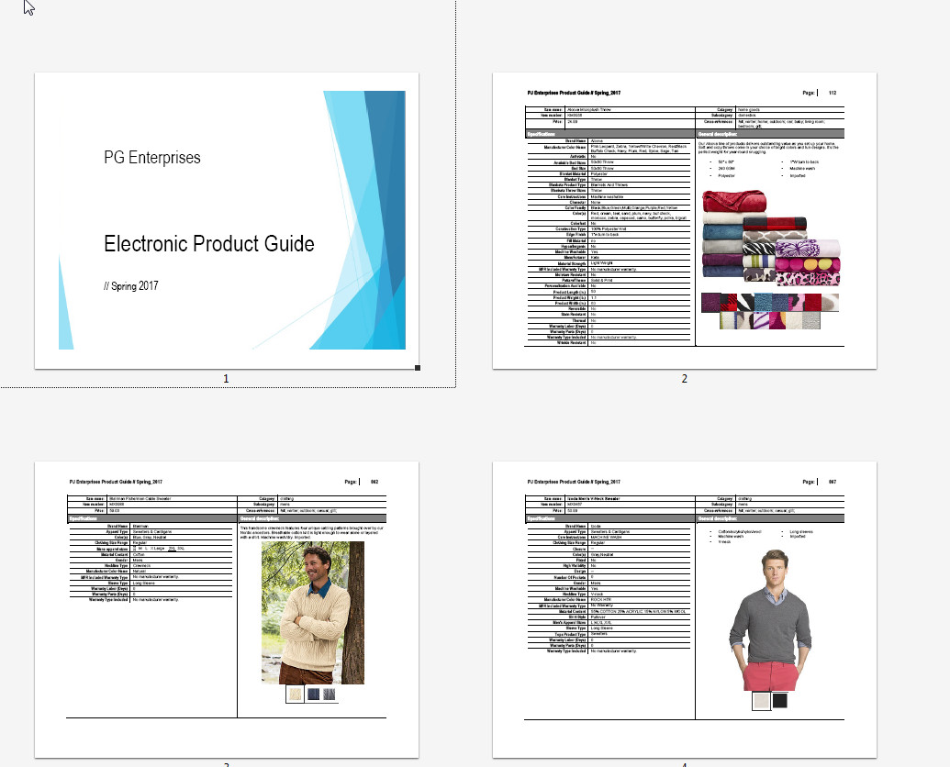

# Appendix D:  Electronic Product Guide Quick

# Reference Aid (Cheat Sheet)

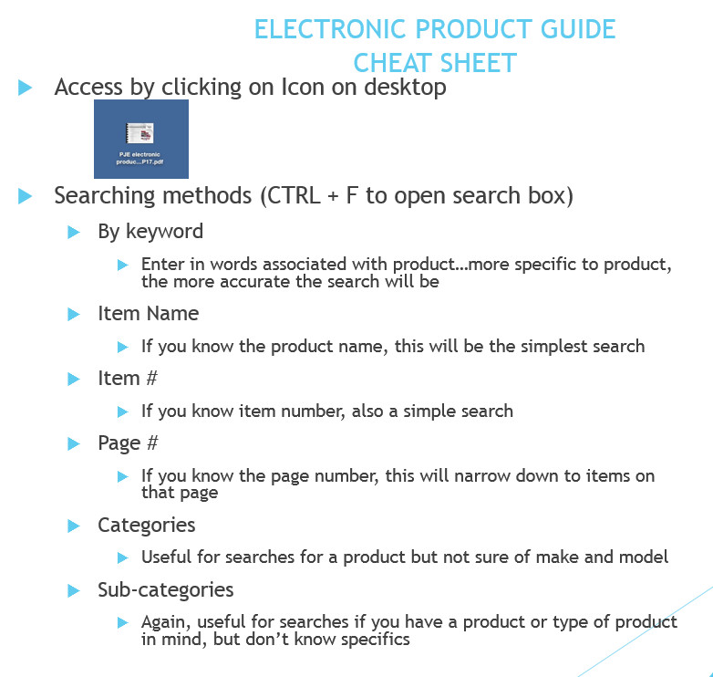

# Appendix E:  Scavenger Hunt Practice Exercise (Answer Tally Sheet)

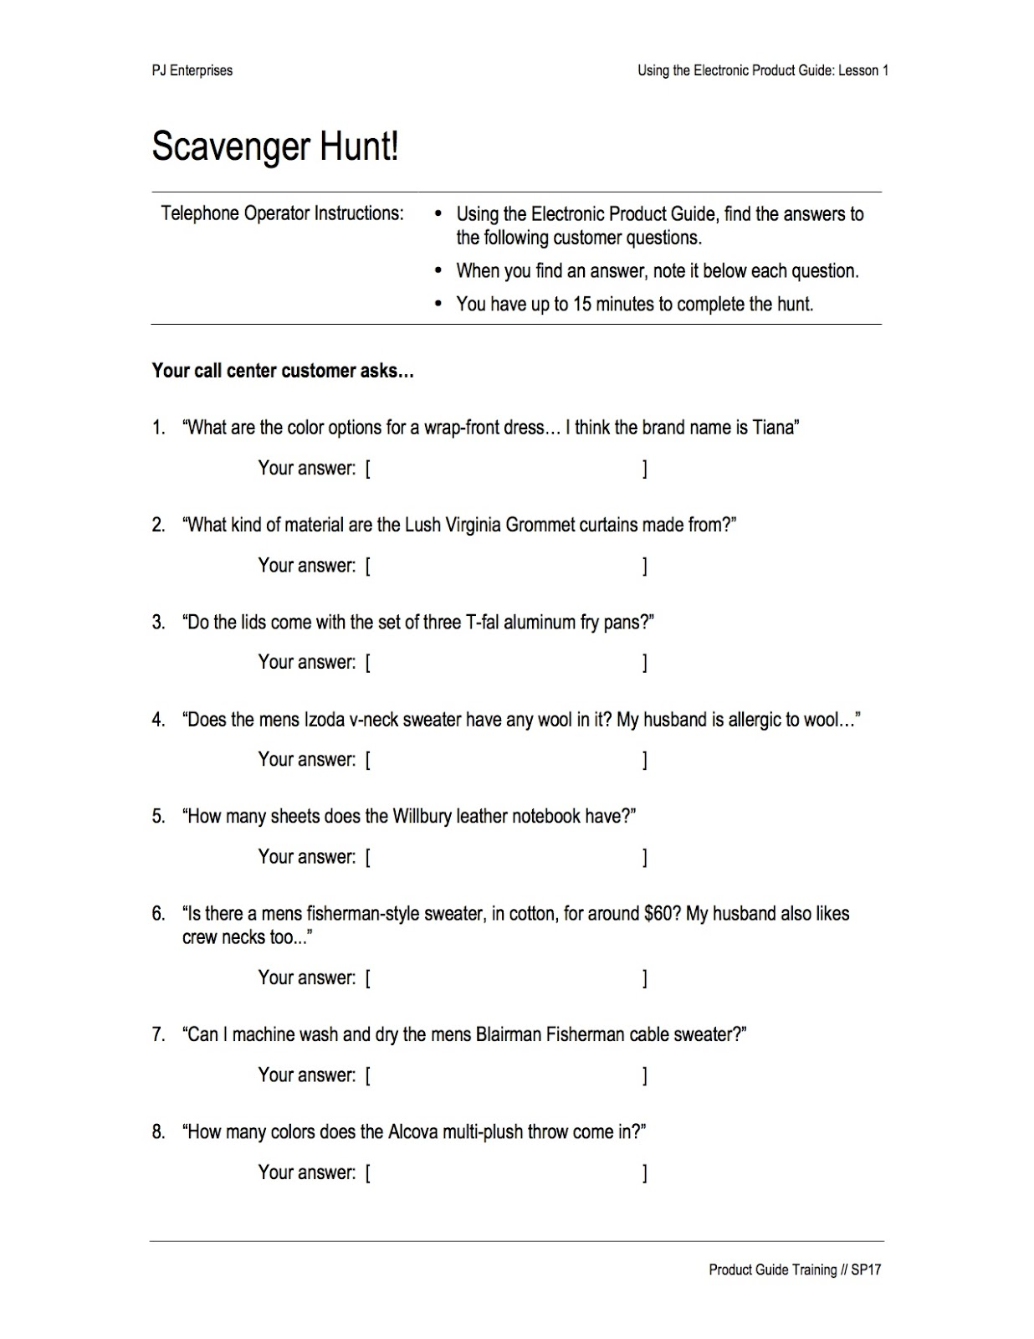

# Appendix F:  Scavenger Hunt Answers

