Design Document for
EDUC 767: Intro to Kentucky
By Rob Ellington

Purpose of the Course | give context and a background of history, sociology, geography, economics and politics and government for present day Kentucky for students, professionals, and new residents.
Audience Description | The target audience for this course will be high school students who may not have taken Kentucky history in eighth grade, out-of-state college students, new state residents, and those who want to learn the background and the history of the state for professional development
Major Course Objectives (Terminal) | TO1- Learners will be able to demonstrate knowledge of Kentucky history from the first American Indian inhabitants to modern day Kentucky  TO2- Learners will be able to correctly identify and analyze social and demographic aspects of the state.  TO3- Learners will be able to identify and analyze the differences in the geographic regions in the state, including cities, counties and regions.  TO4- Learners will analyze economic trends and growth in the state  TO5- Learners will analyze the political history of the state, and how politics shapes government at the local and state levels, and the role it plays in federal representation.
Course Enabling Objectives | - recognize key moments and dates in Kentucky history  - recognize key characters and their role in Kentucky history  - Identify the characters and moments in state history with how those events can be contextually led to today’s Kentucky  - Identify the demographic breakdown of the Kentucky people, and analyze any changes or anomalies that they may discover  - Identify different cultures within the state, and how they may be influenced from inside the state borders as well as outside the borders.  - Identify key population centers, as well as smaller cities that play a key role in the today’s Kentucky  - Identify the geographic breakdown of Kentucky, and analyze any changes or anomalies that they may discover  - Identify different geographic areas within the state, and how they may be influenced from natural bodies, topography, and the people  - Identify the key population centers and how they are in relation to the geographic areas.  - Recognize early economic drivers for inhabitants in the early years of settlement of Kentucky  - Analyze the role of agriculture in Kentucky’s economy, what changed have taken place over history.  - Identify modern economic drivers in modern day Kentucky and recognize how growth can accelerate  - Review the roles political parties have had in state and federal government history, and analyze how it has changed or stayed the same over time.  5.2 Identify the makeup and roles of state level government  5.3 Identify the makeup and roles of local level government.
RLO Enabling Objective | Identify the key population centers and how they are in relation to the geographic areas.
Learning Assessment for Course | The learner will be assessed via activities throughout the units in the course, and will be assigned a percentage grade at the end of the course. High school and college students’ grades will be assigned per the institutions grading scale, while adult learners will earn a certificate of completion.
Learning Assessment for RLO | Assessment will be describing driving directions from one point of interest to another (cities, towns, landmarks). This will be open ended and there will also be knowledge checks, (i.e. multiple choice, T/F) interspersed throughout the lessons.
Instructional Delivery method for Course (overall) | This course will be offered as an online course.
Instructional Strategy for RLO | This RLO will be a tutorial that will describe geographic layout in relations with key landmarks, and contain knowledge checks that will have the learner identify those landmarks. The RLO will end with an exercise that will ask the learner to describe directions one would take from landmark to landmark with details of road #s and other landmarks in route.
Media | Text and graphics will the main components of media used in the course. There will be audio narration of the text content. There will also be hyperlinks for external links to map in the RLO developed.
508 Accommodations | Contrast with background and text will be taken into consideration. Audio narration available for text. Captioning and transcripts will be available for video content if needed. There will be option to skip through repetitive screens, or if user feels knowledge for material is sufficient.
Course Structure Description | There are five units, each consisting approximately between two and four lessons. Information will be delivered through computer-based lessons, with optional group discussions and assessments in the application of the content covered in the lessons.
Seat Time of Course | Six hours
Seat Time of RLO | 15-20 minutes
RLO Outline | - State Layout- “This is Kentucky”  - State-wide Maps  - Physical Map (Google)  - Identify natural components (rivers, lakes, mountain ranges  - Road Map (state official)  - Identify roads and thoroughfares (Interstate, US roads, key state roads)  - Region Identification “What is in Kentucky”  - Map with regions detailed  - Map with cities  - Top 15 cities  - Key historical towns  - Knowledge Check Quiz “Knowledge Check”  - Identify cities and landmarks  - Assessment “Map it Out!”  - Directions assessment
RLO Flowchart | 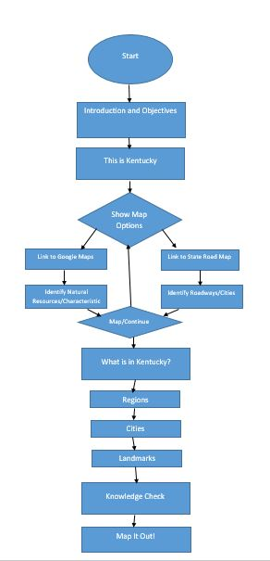
Screens/Pages in RLO | 15-20 (including knowledge check and assessment)
Knowledge Checks or Other Assessments or Practices for RLO | - Dichotomous (T/F, Y/N, etc.)  3- Multiple Choice  3- Multiple Select  - Drag and Drop  - Other – Open text description of road directions
Rollovers/click events | 2 - Rollovers  5-Click Events
RLO Navigation | Each screen will have a <Back> and <Next> button. There will be a menu available with the outline of the content. At any time, the user will be able to exit the program via an <exit> button. There is also a dual choice option for map viewing, there will be an option on those screens to switch back and forth.
Screen Layouts for RLO | 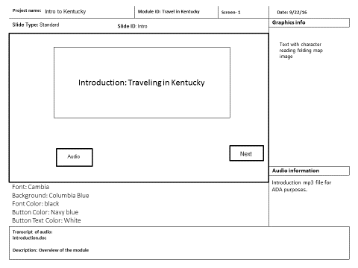  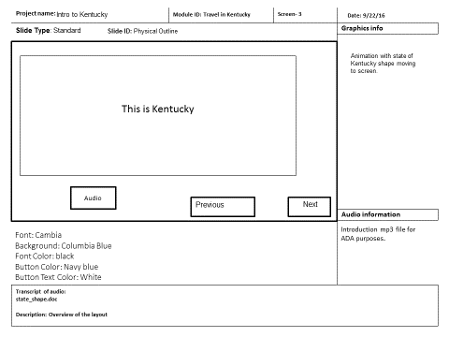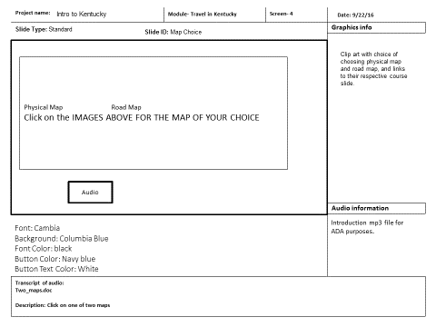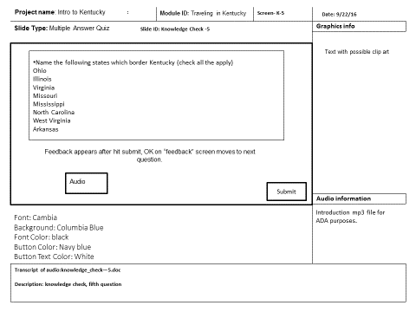
Development Tools for RLO | PowerPoint for storyboarding  Articulate Storyline 2 for RLO authoring, quiz authoring, and publishing
Ownership | Rob Ellington will develop the initial course; however, state history subject matter experts (appointed history instructors, developer) will maintain the course. Course is being developed for the Kentucky state Department of Education.
Development Time of entire course and RLO | Two weeks (80 hours) development time for the course. Ten (10 hours) for this RLO.
Support requirements for RLO and course | Low-level requirements, need SME assistance for review
Project  Sign-off [optional] | Please sign below indicating agreement with the proposed course plan and approving start-up of the storyboard and development phases.
 | Instructional Designer Date
 | Project Manager/Sponsor Date

